RAPPORT PROJET

JAVA/POO/UML

Cesi Exia

A1-2018

* Group members:

MAITRE Maxime

AZZOUZI CLAUSEL Zacharia

BOULESTEIX Tristan

KARDOUS Jean-Pierre

Summary

I. Context/Goals 2

II. Projected schedule / Real schedule 2

III. 2

IV. Implementation of the UML 3

A. Diagrams 3

1. Class diagram 3

2. Diagram of packages 3

3. Diagram of components 4

4. Sequence diagram 4

B. MVC 5

1. Model 5

2. View 5

3. Controller 5

V. Organization of the database 5

A. Entity relationship diagram 5

B. SQL 6

VI. Codes 6

VII. Conclusion 6

A. Conclusion of project 6

B. Problems encountered 6

C. Group report 6

D. Personal report 6

# Context/Goals

The main goal of our project is to recreate the Lorann video game in Java language with five different levels and a spell to kill the demons who pursue it. The levels are stored in a database.

|  |  |
| --- | --- |
|  | Lorann, the main character |
|  | The multicolored spell |
|  | Energy sphere |
|  | The exit door of the level |
|  | The impassable elements of scenery |
|  | The four demons |
|  | Treasures to earn points |

Figure 1- Different sprites used

The figure above shows the different sprites that are given to us and that must be used for our program.

# Projected schedule / Real schedule

# 

# Implementation of the UML

## Diagrams

### Class diagram

### Diagram of packages

To create the diagram of packages, we used the class diagram. In fact, we took the name of the different packages and we linked them together with dependency links.

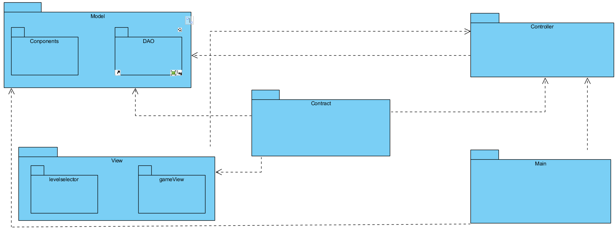

Figure 5- Diagram of Packages

### Diagram of components

To create the diagram of components, we used the MVC model. Moreover, we used the diagram of components already given.

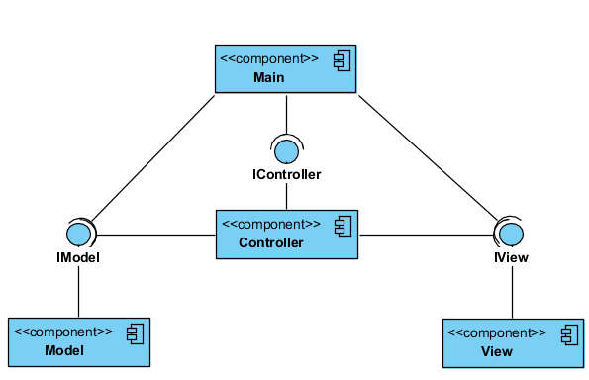

Figure 6- Diagram of components

### Sequence diagram

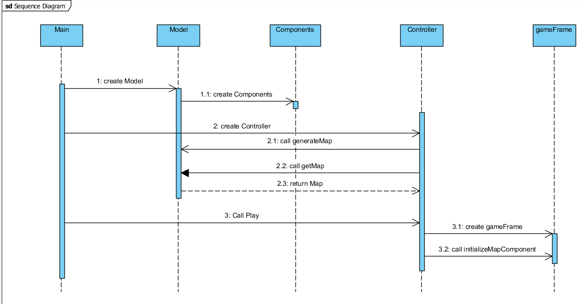

Figure 7- Sequence diagram

## MVC

### Model

### View

### Controller

# Organization of the database

The database is used to store the different levels which are related with maps.

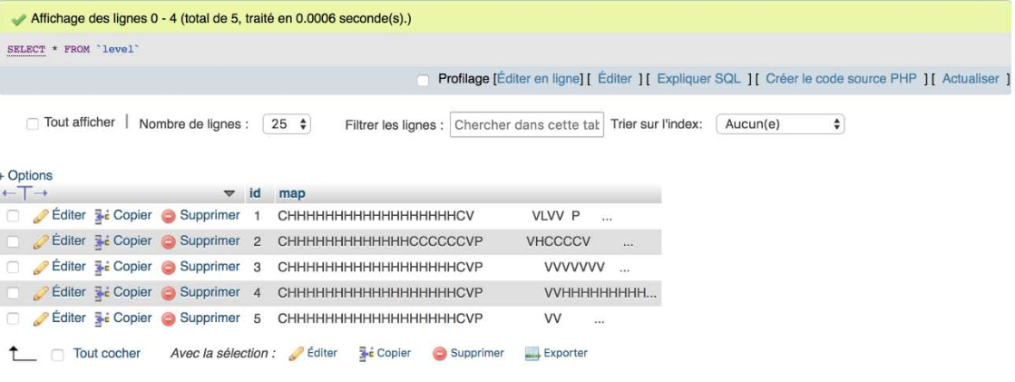

Furthermore, we used stored procedure to find a map by it ID. We select the map we want to display. This map is stored in the table “level”.

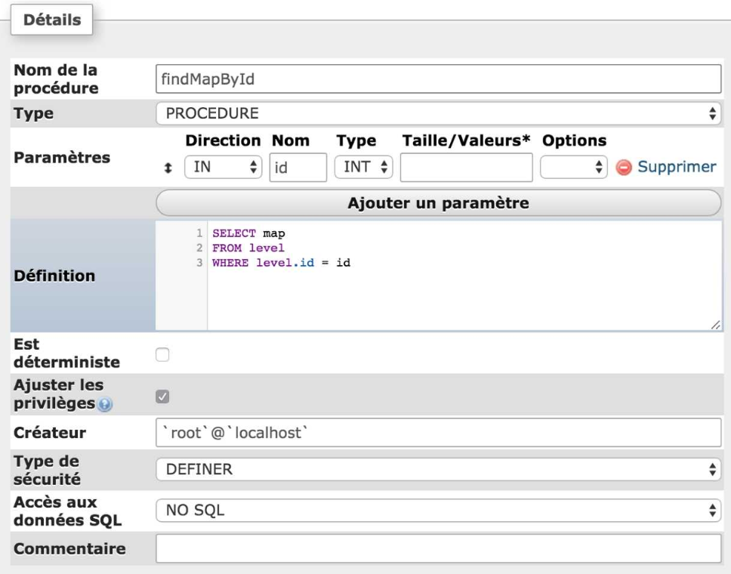

## Entity relationship diagram



Figure 8-Entity relationship diagram of project

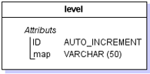

Figure 9- Logical model of data

## SQL

# Codes

# Conclusion

## Conclusion of project

## Problems encountered

## Group report

## Personal report